IOT BASED NOISE POLLUTION MONITORING SYSTEM

INTRODUCTION

Internet of things or commonly called IoT refers to the network of physical devices, vehicles, electronic appliances and other items embedded with sensors, software and connectivity which enables these things to connect, collect and exchange data without requiring human-to-human or human-tocomputer Interaction . IoT is currently growing due to some factors such as convergence of multiple technologies, real time analytics, machine learning, commodity sensor and embedded systems . The term IoT was firstly coined by Kavin Ashton of Procter and Gamble and later by MITs Auto-ID centre (1999).Cisco System estimated that IoT was developed between 2008 and 2009 . It is widely used in today’s applications such as consumer, commercial, industrial and infrastructure spaces. There is a lot of thing that can be implemented for the consumers’ daily uses. Take a smart home for instance, IoT is used in this invention to control lighting, heating, air-conditioning, media and security Systems

PROBLEM DEFINITION

Noise monitoring is very crucial since 20% of the European Union (EU) population or close to 80 million people suffer from noise level that experts consider to be unacceptable . IoT allows an exchange of information to and from a device or thing and due to its flexibility and low cost, IoT is getting popular day by day . Thus, IoT is very suitable to be implemented in monitoring the noise level in some areas to deal with the problem. The demands of modern society lead to the creation of noise sources such as industrial sources, transport vehicles, defence equipment and construction. The most significant example is inside UTM. Noise coming from vehicles and construction sites have significantly distract the focus and the intellectual development of the students. This issue results in the needs of a system that will monitor the noise level at that areas. It is also an alternative for students to know the suitability to study via app

Methodology

Hardware Development

For the hardware parts, LM 393 sound sensor is used to read the readings of the sound level for the environment. The reading of sound sensor calibrated using the real sound level meter to get the accurate readings of the sound level. The 16x2 LCD will show the values of sound level at that researched area and give the warning that says the level of sound is high when the measurement exceeds the set value. If the users could not read the readings due to poor eyesight, they can know the level of sound by using the light emitting diodes (LED) which in red, blue and green colour placed below the LCD. LED acts as an indicator to indicate when the noise is very high. It will turn to red, blue for low noise while green for intermediate level. All these components such as sound sensor, LCD, and LEDs will be connected to the ESP8266 NodeMCU.

App Development

As the app was created by using Android Studio, the app will display the data taken from the sound sensor. Android Studio is a software to create app use JAVA language to design an Android development. The app has four features which are the reading of sound level in dBA, the level of warning based on the reading of sound intensity, the possible sound that contributes to the sound level and the suitability for students to study. The app gives different level of warning such as “low”, “normal”, “high” and “very high”.

OBJECTIVES

The increasing air and sound pollution is one of the significant issue now days. As the pollution increasing it is giving rise number of diseases so, it has become essential to control the pollution for better future and healthy life .here we propose an air quality as well as sound pollution monitoring system that allows us to monitor and check live air quality as well as sound pollution monitoring in particular areas through IOT . System uses air sensor to detect or sense presence of harmful gases, compounds in the air and constantly transmit data to microcontroller. Also system keeps measure sound level and report it to the online server over IOT. The user friendly and easy handling of the system technology is such that it can be installed in houses, schools and in small places. KEYWORDS: AurduinoUno Gas Sensor MQ135,Sound Sensor LM393,Wifi Module.

WOKWI

Wokwi is a versatile online platform that allows you to design ,simulate, and test electronic circuits in a virtual environment.

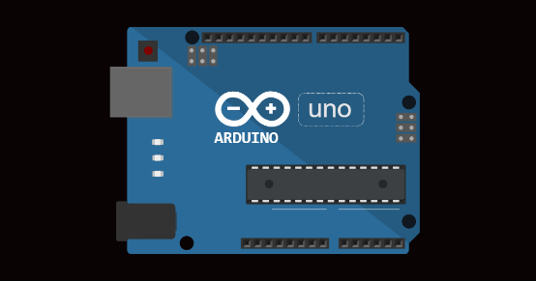

<https://wokwi.com/arduino>

Components Required

1. Sound level meter (SLM)

2. Frequency Analyser

3. Microphone

4. Windshield

5. Data storage

6. GPS module

7. Calibrator

8. Data analysis software

9. Weather monitoring equipment

10.Continuous monitoring system

11.Remote communication

12.Power source

13. Mounting equipment

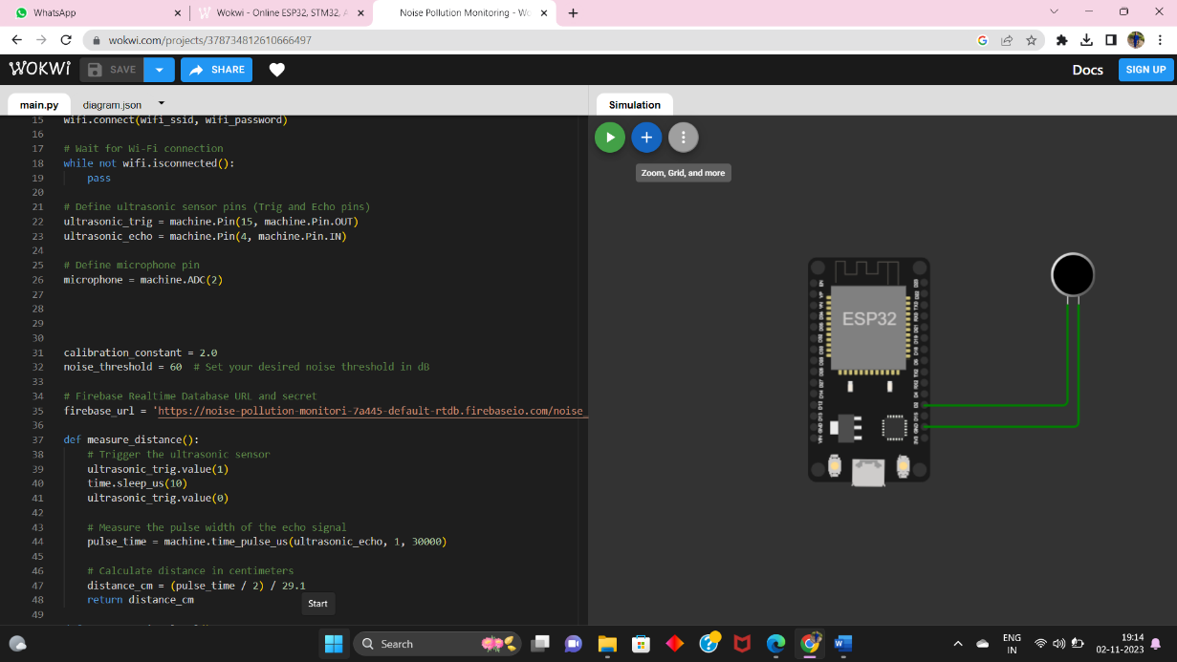

Code Description

Suppose the sound sensor sends an analogue voltage signal to Arduinos analogue pin

(A0). This voltage is representation of another noise .

Int sensor pin =40

Output

Int sensor value =0;

the sensor

int threshold =512;

void setup()

{

Serial. Begin (96000);

}

Void loop ()

{

Sensor value = analogue Read (sensor pin);

From the sensor

Serial .print in (sensor value);

If (sensor value> threshold )

{

Serial .print (“ high noise level !!!...”);

Result Analyse

This project aim to create a noise pollution monitoring using Wokwi , integrating a sound level or a compatible micro controller with virtual components such as microphone ,frequency analyser wind shield .The simulation successfully monitors sound level causing the led to blink . This project show case the ability of virtual components to emulate the functionality of a real word system within a simulated environment .

Conclusion

The wokwi based noise pollution monitoring simulation project effectively illustrates the control and monitoring of sound level using a sound level meter and virtual components . The project demonstrate the practically of using wok wi virtual environment for hardware simulation ,allowing precise testing and visualization of system functionality without physical components . The LED and sound stimulator responded to sound level changes as expected ,show casing the potential for virtual hardware modelling